TR6 FRONT BRAKE CALIPER KIT with WILWOOD ROTORS INSTALLATION INSTRUCTIONS

Braking needs vary from one vehicle to another due to tire size, suspension settings, weight and other factors. Good Parts makes no recommendation as to the suitability of a particular caliper, piston size or brake pad combination for your vehicle.

**WARNING:** Optimum braking is achieved with the correct balance of front to rear bias. Too much braking power in the front reduces overall braking because the rear is contributing less. Too much rear braking is very dangerous because rear wheel lock-up can cause the car to spin out of control.

**TEST YOUR BRAKES** in a safe place where there is no danger to (or from) other people or vehicles **BEFORE** driving on the street.

1. Remove the original caliper and its attached brake line and disconnect the brake hose from its attachment point at the frame and from the hard brake line. Leave the dust shield in place.
2. Remove the hub from the spindle and remove brake rotor from hub.
3. Bolt the aluminum rotor hat to the original hub using the ³∕₈-24 bolts and lock washers supplied. Use medium strength thread locker and torque to 40 ft/lb. With Good Parts alloy hubs, use the ³∕₈-16 x 1³∕₄" bolts and lock washers supplied with the hubs and torque to 35 ft/lb.

**NOTE:** The rotor hat is a slight interference fit on the hub so it helps to warm the hat before installation. The bolts may be used to pull it evenly onto the hub.

1. After the hat has cooled, bolt the brake rotor to the hat using the ⁵⁄₁₆" bolts and lock washers supplied. Use medium strength thread locker and torque to 22 ft/lb. This is also a slight interference fit so warming the rotor will help. Use the bolts to pull the rotor evenly onto the hat.
2. Drain and flush the master cylinder and lines with fresh DOT 3, 4 or 5.1brake fluid.
3. Remove the center bolt and spacer and the spring clip from the new caliper and install the brake pads. Re-install the center bolt and spacer and spring clip.
4. Bolt the new caliper in place using the new bolts, lock washers and flat washers supplied as follows. Use a lock washer next to the head of the bolt, then a flat washer. Next will be the dust shield, then the caliper mounting ear, a flat washer used as a spacer, then the mounting bracket. Three thicknesses of flat washer are supplied. Choose the thickness of washer or combination of washers to go between the caliper and mounting bracket that best centers the caliper on the rotor. Be sure to use the same thickness spacer on both mounting ears. Use a thick enough washer(s) at the head of the bolt to keep the end of the bolt from protruding through the mounting bracket far enough to interfering with the rotor. Use medium strength thread locker on the threads and torque to 55 ft/lb.
5. To help prevent brake squeal, I suggest using the Disc Brake Quiet included with the brake pads. Thoroughly knead the packet before opening. Apply a thin, even layer over the entire steel back of each brake pad, stopping just short of the edges. Do not get any of the material on the edges of the metal backing or on the friction surface. The manufacturer’s description says their product forms a plastic film between the piston and pad to prevent squeal. The instructions do not mention a drying time before installation of the pads. I feel that the material should be well dried before installation but you can use your judgement. Remove the center bolt and spacer from the caliper and install the brake pads. Re-install the center bolt and spacer.
6. Remove the cover from the caliper inlet port in the center of the back of the caliper. Apply thread sealant to the tapered threads of the 90 degree fitting and thread it into the caliper. It should be pointed forward slightly up so the flexline clears above the steering arm.
7. Thread the flexline onto the fitting and tighten.
8. Thread the short end of the bulkhead fitting into the free end of the flexline and tighten.
9. Thread the long end of the bulkhead fitting through the bracket on the frame, install the star washer and nut and tighten.
10. Thread the nut of the hard brake line onto the bulkhead fitting and tighten.
11. Turn the steering wheel full left and right and make sure than the flexline is free of any obstruction as the suspension moves.
12. Fill the system with high temperature DOT 3, 4 or 5.1 brake fluid and bleed the air using the small bleed screws on the top of the inside and outside of each caliper. DOT 5 fluid is not recommended for any racing application due the possibility of boiling of collected moisture in the system. Also, DOT 5 fluid is highly compressible due to aeration and foaming under normal braking conditions, providing a spongy brake feel. Dot 5 fluid is best suited for a show car where its anti-corrosion and paint friendly characteristics are important

**PARTS LIST**

1 - Instructions

2 - Rotor, 11”

2 - Rotor mounting hat

2 - Hydraulic brake caliper

2 - Flex line

2 - Fitting, bulkhead

2 - Fitting, flare to NPT, 90 degree

2 - Nut, jam, ³∕₈ - 24

2 - Washer, internal star locking, ³∕₈"

4 - Bolt, hex head, ⁷⁄₁₆ - 20 x 1³∕₄" Grade 8

4 - Washer, split locking, ⁷⁄₁₆"

8 - Washer, flat, ⁷⁄₁₆" SAE, thin

4 - Washer, flat, ⁷⁄₁₆" SAE, medium

8 - Washer, flat, ⁷⁄₁₆" SAE, thick

8 - Bolt, hex head, ³∕₈ - 24 x 1¹⁄₁₆" NAS

8 - Washer, split locking, ³∕₈"

12 - Bolt, hex head, ⁵⁄₁₆ - 18 x 1", Grade 8

12 - Washer, split locking ⁵⁄₁₆"

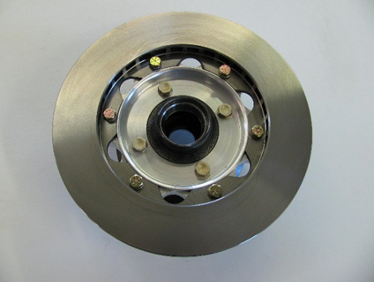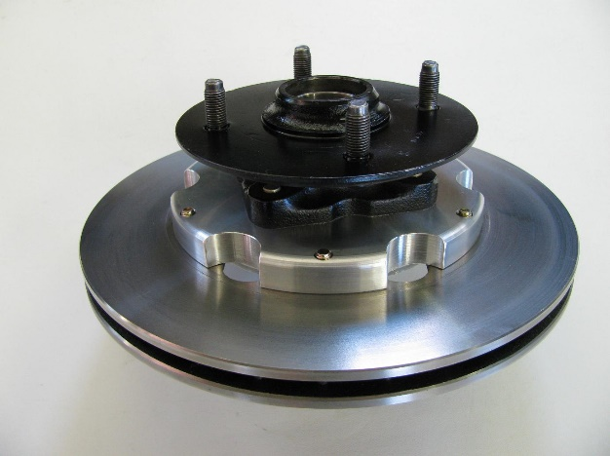

**Good Parts Inc.**

**Richard Good**

**4316 New Holland Rd.**

**Mohnton, PA 19540**

**(610)777-4457**

**goodparts@verizon.net**



**PAD AND ROTOR BEDDING**

Bedding is a "real conditions" heat cycle and the final step in preparing the pads and rotors for service. All pads, even OE stock replacement parts, will benefit from a proper bedding cycle. All rotors, especially cast iron rotors that will be operated at sustained high temperatures, will provide longer service life and smoother braking when properly bedded. Bedding can be done either in the vehicle, or on a special bedding dyno that can realistically duplicate the torque loads, pressure, and temperature that will be realized in the vehicle.

**ROTOR BEDDING**

Rotor bedding is an essential element to high level performance and durability. It is most critical with cast iron rotors. Cast iron is extremely well suited to use as a brake rotor, but it can be susceptible to thermal stress, distortion, and even cracking if subjected to rapid changes in temperature when it's new. The cracking sound that you may hear when pouring a favorite beverage over a glass of ice is thermal shock. A proper bedding cycle will gradually bring the rotors up to temperature and then allow them to cool slowly and completely in order to "season" and relieve any remaining stresses from the casting and machining processes. With some compounds, a layer of pad material may also be embedded onto the rotor face. It is important that this "transfer layer" be deposited slowly and smoothly. Otherwise, pedal pulsing and compromised friction values can result.

**PAD BEDDING**

The bedding process is the final "heat cure" for the pads. This final bedding cure differs from an oven heat cure in such that the oven heat cure does not include the pressure, torque, and elevated surface temperatures that are necessary to properly condition the pad for service. As it is with the rotors, new pads must be gradually brought up to temperature and then slowly cooled. If the pads are put into hard service right from the start, damage from fractures or accelerated deterioration due to extreme temperature variations between the surface and the body of the pad can occur. Overall poor performance with the potential for rotor damage are often the results.

**BEDDING STEPS**

Once the brake system has been tested and determined safe to operate the vehicle, follow these steps for bedding of all pad materials and rotors.

1. Begin with a series of 8-10 light stops from approximately 30 MPH down to 15 MPH allowing 20-30 seconds for cooling between each stop.
2. Progress with a series of 8-10 moderate stops from around 45 MPH down to 30 MPH allowing a 20-30 second cool down period between each stop.
3. Proceed with a series of 8-10 hard stops from 55-65 MPH down to 25 MPH allowing 20-30 seconds of cool down time between each stop.
4. Drive at a moderate cruising speed, with the least amount of brake contact possible, until most of the heat has dissipated from the brakes. Avoid sitting stopped with the brake pedal depressed to hold the car in place during this time. Park the vehicle and allow the brakes to cool to ambient air temperature.

**NOTES:**

During the bedding process, a more positive feel from the brakes should develop. This is an indication that the bed in process is working. If any level of brake fade is observed during the hard stops, it may be an indication that the brakes have been more than adequately heated. Begin cooling the brakes with light driving and without brake contact immediately.